Supporting the Individual Journey through integrated
Health and Social Care
Investigating Health and Social Care Services
For the Individual
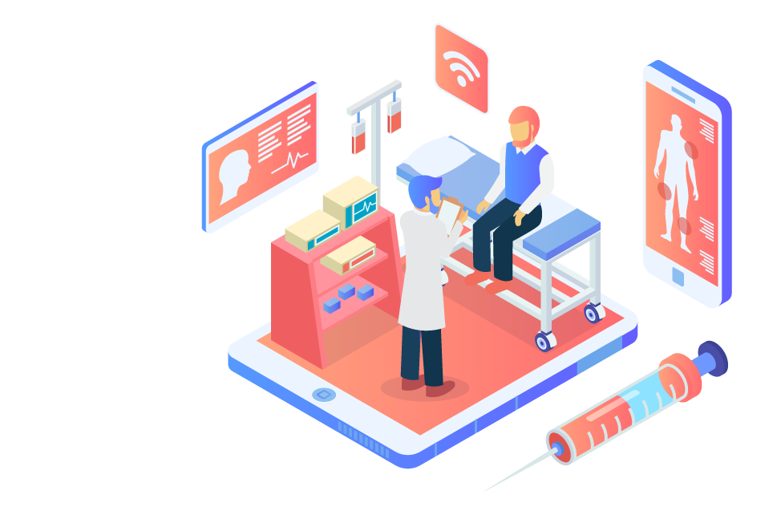
Table of Contents
1 TASK 1 3
2 TASK 2: 6
2.1 Needs 6
2.2 Outcome 6
2.3 Implementation 6
2.4 Evaluation 6
2.5 Some of the social care areas would be, 8
2.5.1 Interpersonal Skills 8
2.5.2 Effective listening 8
2.5.3 Socializing 8
2.6 Multidisciplinary activities 9
2.7 Communication styles for the caretaker 10
2.7.1 Assertive communication tone 10
2.7.2 Respecting the Feeling 10
2.7.3 Patience 10
2.8 Reflection 11

TASK 1
It is provided that the care services for the elderly are one of the most important aspects for any of the nation. The person that served the nation through any profession and helped the country to get along with a hard time deserves the best health care services. For the health care services, they must be according to the requirements of the people; they should meet the minimum as well as the maximum service quality requirement that could be needed. Through the study, it is found that integrated services are the method through which better and efficient services in the health care sector are provided (Simbolon, and Simbolon, 2018). For the people it is important to understand and acknowledge the issues of the elderly, and how much they require health care services. Through the concept of integrated health care services, the people at the fitness care institutes provide the best services through coordination, collaboration, and more of such strategies.
Integrated services are the way to improve the services for the patients including the elderly people's health care service. The policies that are required for the health care services are also developed through the focus on integrated services. There are several features or elements through which the integrated services concept would get implemented. One of the principles that are focused on through integrated care system is collaborative leadership (Saxe Zerden, et al 2019). Through the merger of the two leadership styles of trying to settle down the thing through the incorporation of the two methods, the results would be highly positive. Also in the adoption of the leadership, it is found out that the style through which the maximum issues are getting effectively solved should be implemented, there should be no rigidness in the leaders or the style they follow so that the result would be productive in the service providing. Asset-based management, positive and successful arrangement from the local resources or system would be highly beneficial and is an important aspect of the integrated care system.
According to the findings, several issues could be highlighted through the research in this context including the lack of funding from the central source for the health care system to meet the local needs of the system. It is found out that the country of the United Kingdom spent around 269.5 billion British pounds, which is massive (Healthcare expenditure UK 1997-2020 | Statista, 2022). The budget that is invested by the United Kingdom despite spending such a huge amount is unable to meet the requirements of the people, which are alarming; as such issues will result in the health system of the people.
Health care providers are the entity that can provide the health care services to the people with the agreement with NHS that is the National Health Service in the country of United Kingdom. The health service provider can run the single or the multiple in or outside of the hospital. It is the organization that is directly providing health care services to the people of that region. The services that are directly related to the illness, prevention of it, treatment, injury, disability, or aftercare are included in the system of the health care services.
While the other category of the services that could help people lives their life better is the social care services that are mostly related to assisting with the issues of life aspects (Thorlby, et al 2018). Personal care is one of the major aspects that could be included or counted as the core aspect of the social care service. For the person not only it is important to get or seek the assistance of the professional when they become ill, but the social service including the feeding, taking, dressing, and other critical everyday life aspects are included in the social care services which are also vital in the life of the person.
There are three provisions which are formed through which the health care services are provided to the people including the,
- When a Health Care Provider is an Organization
- A Health Care Provider is an organization acting as a direct provider of health care services.
- A Health Care Provider is a legal entity, or a sub-set of a legal entity, which may provide health care under NHS service agreements; it may operate on one or more sites within and outside hospitals.
The system through which the families of the people and the authorities come together in the way to assist with the interrelated services is known as the inert-agency collaboration. It is a very important aspect of society that the different authority gets connected through which the results would be more effective in the care sector (Yatsco, et al 2020). The major concept of the inter-agency is that it focuses more on the integration of the departments or the complete organizations as compared to the individual professionals. Through the provision and the proper identification of the needs and the requirements of the elderly the benefits that could be gained through the services of the inter-agency include better access to the services, elimination of the replication of the services provided by the several health care providers, and more efficient services. Through focusing on the provisions of the interagency, the issues of the family including having an elderly and children get tackled proactively.
Another effective way through which the local requirements can be catered to is the (MDT’s) Multidisciplinary teams. In the United Kingdom, the concept of the Multidisciplinary teams provides health care services through bringing the different health care professionals together, that coordinate, plan and develop the effective model of providing services to the people (care, et al 2022). The hospitalization is a burden on the health care sector, the MDT provides social, health, and other care services to the people so that they will be more independent in their lives by providing the right service to the right home.

References
care, I., practice, R. and teams, M. (2022) Multidisciplinary teams - Activities to achieve integrated care, Social Care Institute for Excellence (SCIE). Available at: https://www.scie.org.uk/integrated-care/research-practice/activities/multidisciplinary-teams (Accessed: 24 February 2022).
Healthcare expenditure UK 1997-2020 | Statista (2022). Available at: https://www.statista.com/statistics/317669/healthcare-expenditure-in-the-united-kingdom/#:~:text=Healthcare%20spending%20in%20the%20United,the%20previous%20year's%20healthcare%20spending. (Accessed: 24 February 2022).
Saxe Zerden, L.D., Lombardi, B.M. and Jones, A., 2019. Social workers in integrated health care: Improving care throughout the life course. Social Work in Health Care, 58(1), pp.142-149.
Simbolon, P. and Simbolon, N., 2018. Association between Social-Cultural and the Utilization of Elderly Integrated Health Services (Posyandu Lansia) in Hamparan Perak Health Center. Unnes Journal of Public Health, 7(1), pp.50-54.
Thorlby, R., Starling, A., Broadbent, C. and Watt, T., 2018. What's the problem with social care, and why do we need to do better?. King's Fund.
Yatsco, A.J., Champagne-Langabeer, T., Holder, T.F., Stotts, A.L. and Langabeer, J.R., 2020. Developing interagency collaboration to address the opioid epidemic: a scoping review of joint criminal justice and healthcare initiatives. International Journal of Drug Policy, 83, p.102849.

TASK 2:

Needs
The portion of the needs is the aspect through which the personal care aspects including the personal and social care are identified. Through the identification, it will assist in taking care of oneself in a more effective manner. The needs of the person must be effectively identified so that the personal care would be according to those needs.

Outcome
The results that will be gained through those needs or the implementation of those personal care elements would be the outcome. The outcome is the major motivation for personal care. If there would be no outcome then the person will not do that activity, as there would be no gain.

Implementation
The third element of the personal care plan is the implementation, of the activities or the plan that is developed. Through the phase of implementing the activities are executed in the best way possible.

Evaluation
The evaluation section of the personal care plan includes the assessment of how to check whether the activities help in accomplishing the goals or not. The evaluation also helps in finding out the progress that is achieved through the implementation of the activity.
The below personal/ self-care plan will provide effective insight about how one can take care of themselves.

CARE ASSESSMENT PLAN

Name: Anonymous |  | Contact Details:
Needs | Outcome | Implementation | Evaluation
- Brushing teeth two times a day | Teeth would be flawless and there would be no food or bacteria residing on teeth. | To implement the brushing of teeth twice a day, a sticky note with the table of every day mentioned with two times will be posted on the fridge, that will keep on reminding about the activity of brushing teeth two times a day. | Through the persona look on the teeth or the appointment to the dentist, results could be evaluated.
- Dressing up | It will provide a confident outer look. | Go to the wardrobe and select the best suited and comfortable outfit, that not only provide me comfort but confidence too. | Through looking up into the mirror.
- Going for the complete body checkup | Help to identify minor or major issues in the body related to health | Book an appointment with the family doctor that will check and test for any issue that might harm in the future or is creating problems currently. | It would be evaluated by the reporting physician will provide.
- Oiling hairs | Provide shine and strength to the hairs and also give the feeling of being relaxed | Bring the massage hair oil from the grocery store and apply it on the hairs | The health of the hair will be evaluated through softness.
- Cutting nails | Give the best shape to the nails | Find the nail cutter from the personal care section and cut the nails. | The cleanliness of the nails will be evaluated by looking at them.
- Have a massage | It will provide muscle relaxation to the body and energize. | Call for an appointment in the massage parlor. | Through the elimination of all the body pain that is irritating, the massage will be evaluated.
- Calling a friend | Give satisfaction and feeling of being relaxed through talking to the person with whom talking would be positive and productive. | Think about the most understanding person either friend or family and call him/her, ask about the life and their update, and tell them about the personal updates in life. | Through the relief gained after talking to the friend.
- Reading a book | Give me insight about the topic of the book and help in get refreshed. | Find the most interesting book either on the bookshelf or online. | Through getting insight and knowledge from the book.
- Cook something delicious | Found a new recipe according to my taste and try that to give a treat to the taste buds. | Find out the recipe and cook it that will provide a new taste to the taste buds. | It will be evaluated through the taste of the dish being cooked.
- Cleaning the room | Gaining a sense of satisfaction, and being disciplined. | Find out the vacuum cleaner, dust brushes, and start cleaning the required area. | It will be evaluated through the look of the room after cleaning.
- Making wardrobe | Got the sense of being an organized person. | Go to the wardrobe and make it.
- Setting goals for the future including short-term and long-term | Give the foresight of the future and how it is shaping the current day. | Take the pen and the notepad, then after brainstorming find out the short-term and long-term goals. | Through effective discussion from the friends, family, and the councilors the goals will be evaluated.

Some of the social care areas would be,

Interpersonal Skills
These are the skills which are required by the person very much, in the personal and professional life also. Through talking to friends and colleagues, these improvement areas would be effectively covered and are evaluated through the feedback gained from my friends.

Effective listening
Another area of improvement in which there is a lot of room for improvement is effective listening. Through understating the essence of the topic and providing the most suitable suggestion to friends and family these goals will be achieved. Further, it will be evaluated through the results gained from providing the solution.

Socializing
It is one of the major factors through which the personal and professional life aspects will be effectively improved. It will be done through calling the friends and meeting their friends, which will be built confidence and help to improve the quality of socializing with people. It will provide social connections, networking, and benefit also in the long run in life.

Multidisciplinary activities
For the person, he/she the leadership style that will benefit the most would the coaching leadership style. Through the coaching leadership style, the improvement in the life aspects would be gained positively and effectively. Coaching is one of the concepts through which the leader in the organization provides the chance to the employees of him or her that will unlock the potential of the people through effective strategies (Taberna, et al 2020). Coaching leadership style for the person also provides the opportunity taken to improve the weak areas through implementing the best way possible. The leadership style of coaching must be implemented in life that will not only provide a way to improve the weak areas but also help to seek opportunities for improvement.
Also if the coaching leadership style will be adopted by the MDTs it will project a positive impact on the people that it is serving. Through the effective leadership style, there are several ways in which they will help the people. As in the multidisciplinary teams, there are professional that belonged to the different background of the society who come together to help the elderly or people that needs helps, so there should be some management method through which they will effectively provide the service in a managed way (Hastings, and Kane, 2018). Through the method of the coaching leaders, the professionals are coming to help and provide assistance to the needy people. Through the implementation of the coaching leadership style, it will provide the direction that will assist the MDTs to serve in the most suitable way possible. The leadership style for oneself and the authorities also play a vital role in the success of the task execution, so that positive and outcome-based results would be gained.

Communication styles for the caretaker
Although there are many communication styles through which the caregivers can effectively communicate with the people. The social service people and the authorities including the health care service providers can adopt but some of the communication styles that will help to carry out the health and social care services effectively are:

Assertive communication tone
For the care and service provider being assertive may be easy, but for the person seeking help, it plays a significant role. Being assertive in communication relates to the clarity and the directness in the conversation that will cause no ambiguity (Literacy–Assertiveness, 2018). If their instruction would be unclear then it will cause a negative impact on the service being provided, and also the effectiveness will be reduced of the activities that are developed to improve the weak areas of the people.

Respecting the Feeling
One of the most neglected aspects of the communication styles would be the tone of respecting the feeling of others. IT is important for the people that are serving the other people that they should remain respectful in their tones through which the people that are gaining the service will be more comfortable in the service (McCorry, and Mason, 2020). The tone of the caregiver of the MDTs or other service providers if found out to be harsh than will impact the results of the system negatively.

Patience
The politeness and the patience in the tine is an important aspect of the communication strategy from such people. Usually, the people that are taking the service including the elder and children mostly do not properly communicate, due to which the frustration is natural (Ritonga, et al 2020). It is recommended that the tone of the caregiver should be the one through which the patient will remain constant and people will remain positive while receiving the services.

Reflection
I feel that the health care sector is an important aspect of the region through which the people that are living in the country gain effective service regarding their health and care. For every person that is living in the country, social and health care should remain the highest priority by the governmental authorities and not only by them but also by the people themselves. Through the assessment, I have done regarding the personal care and the service that is provided in this domain there are a couple of findings through which I have learned valuable lessons.
Elderly and the children are among the two entities that require the best health and social care service in the United Kingdom. Through the analysis of mine, I came to know that the funding that is provided by the central government is not enough to meet the requirement of the people that are living in the united kingdom, due to which the people are suffering from not only the health issues but either if there are getting the health care service they are not of good quality. For the people, it is significant to get the best and most suitable health and social care services through which they will be able to live their life in an effective and aim full way.
Through the services and the involvement of mine, the services that are identified include the interagency which is one of the effective ways through which the accessibility and the effective way of providing the services will be gained. Also, the role of the health and social care service provider is found to be an important one. Also, another important concept that is helping the people of the United Kingdom to effectively carry out the service of health and social care is the Multidisciplinary teams that are the group of people that are professionals from different backgrounds and joint to help the need seeking people in the services. For the person, it is important to take care of their health not only the physical health but the social one too, which will benefit and shape their personality.
According to tome a through my experience I would say that, although the services of the health and social care system in the united kingdom might not be currently able to completely fulfill the needs of eh people, there is plenty of other quality integrated service through which people can gain the benefit in the domain of their care.

References
Hastings, L.J. and Kane, C., 2018. Distinguishing mentoring, coaching, and advising for leadership development. New directions for student leadership, 2018(158), pp.9-22.
Literacy–Assertiveness, C., 2018. Healthy Thanks to Communication. Optimizing Health Literacy for Improved Clinical Practices, p.124.
McCorry, L.K. and Mason, J., 2020. Communication skills for the healthcare professional. JONES & BARTLETT PUB Incorporated.
Ritonga, S., Riadi, S. and Siregar, Z., 2020. Islamic Communication Model in Therapeutic Communication Practices at Adam Malik Hospital. SIASAT, 5(2), pp.84-93.
Taberna, M., Gil Moncayo, F., Jané-Salas, E., Antonio, M., Arribas, L., Vilajosana, E., Peralvez Torres, E. and Mesía, R., 2020. The multidisciplinary team (MDT) approach and quality of care. Frontiers in Oncology, 10, p.85.

