Why Islam remains politically active in the Middle East
[Author Name(s), First M. Last, Omit Titles and Degrees]
[Institutional Affiliation(s)]

Author Note
[Include any grant/funding information and a complete correspondence address.]

Table of Contents
1 Introduction 4
1.1 Expansions of Islam in the Middle East 4
1.2 Influence of Islam in the Middle East 6
1.3 Political Islam in the Middle East and its Revival 9
1.4 Islam as a determinant factor in Politics of Middle East 11
1.5 Role of Islam and its Significance 13
1.6 Foundation of Civil Law 14
2 Conclusion 16
Reference 18

Table of figures
Figure 1 Countries in the Middle East 6
Figure 2 Pace of religion growing 8
Figure 3 Regional Distribution of Muslims 12

Introduction
Islam is one of the religions that are gaining popularity not in the current era but from the starting when it came. It is significant to study the role of Islam and its influence on the politics in the Middle East through which the shape of the Middle East gets highly molded. Islam in the Middle East not only influenced the lifestyle of the people living but is deep-rooted in the politics of the region. The current format of the study also includes the investigation of the different factors through which the role of Islam in Politics, how it influenced different aspects, and would be the outcome of either welcoming it or not, get discussed in the study. Through the thorough development of the arguments and the literature analysis, the readers will be able to find out the effective insights and the way through which the conclusion and the effective result would get drawn.

Expansions of Islam in the Middle East
The prophet Muhammad (Peace Be Upon Him) in Islam came with a different religion that was currently being practiced in the Arab. His life was completely devoted to the spreading and reaching of Islam, its code of conduct, and the methods through which it will improve the lives of the people hereafter. After the death of the Prophet Muhammad in 632 AD, Arab who were completely became Islamic started to Expanded their land from one end to the other. they fought many wars and conquered several regions across the globe and the day came that Islam become one of the most popular and dominant religions in the world (Budiwati, 2020). Islam is not just the rules and regulations, but it is a complete code of life that gives the life aspects, from marriages to divorce and from legal issues to the governmental policies. Islam expanded to vast areas of the land making it more known to the people of the different religions and people. It was expanded in the era of Four Islam Caliphs from 632 to 661 CE, after them Umayyad Caliphate also expanded the zones of Islam wide. Then came the Abbasid Caliphate and then their decline with the several fragments started to spare the sound of negative and dirty politics in it (Mansour, 2018). Similarly soon after the decline the Ottoman Empire started the revival of Islam and hold control of the land and became the dominant power again, IT is one of the most long-lasting dynasties in history with the spend of the land of the Middle East, Eastern Europe, and North Africa for more than 600 years (Mughul, n.d); though from the starting Islam was used for personal benefits and to gain significance in politics, and after WWI and the dissolving of Ottoman Rule politics become more strong with the Islamic teaching in its presence in very minor segments. Islam provides the way to solve every aspect and to establish every aspect of life. As Arab was located in the Middle East, the countries in it started to accept Islam and now most of the countries in the Middle East are Muslim Nations. The Control of the Ottoman Empire was loosed from many regions and they were limited to the place now known as Turkey, which was once the hub of controlling the politics around the globe through Muslims. But dissolving the Ottoman Empire by the British politics did not give them freehand and Islam from the Middle East did not get vanished and even increased more (Vulture, 2022). People started to understand the conspiracy behind the liberation of land under the control of the Ottoman Empire and started to practice Islam and expand it more. The Middle East remains one of the dense Muslim majority regions with almost every country having a Muslim Majority and control in the hand of Muslim Politicians.

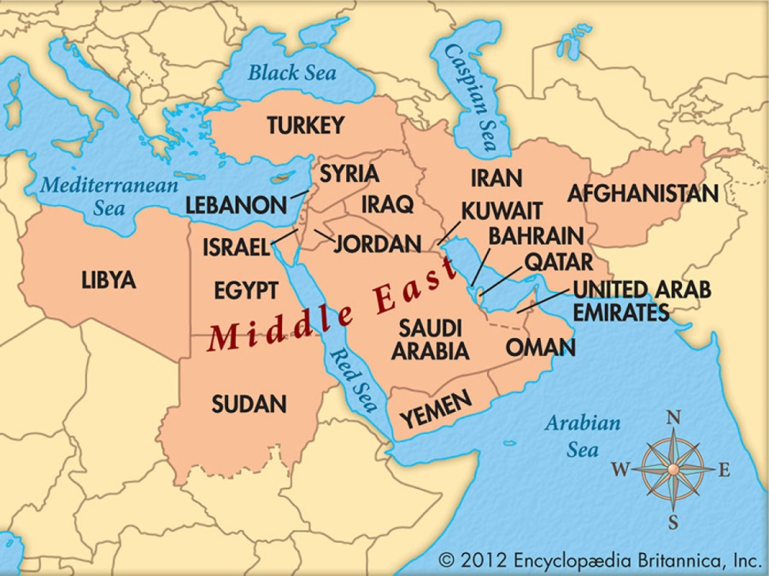
Figure 1 Countries in the Middle East
Source: Vulture, C. (2022). Why is the Middle East called the Middle East?. Retrieved 18 March 2022, from https://www.commisceo-global.com/blog/why-is-the-middle-east-called-the-middle-east
From Fig 1 above it could be easily identified the Muslim, states in the Middle East and the dominance of them in the region as a religion. Through the investigation, it is provided that the Britishers used the land of the Middle East as a Buffer region to reach India, due to which they wanted to dominate on the land (Vulture, 2022). The major blow to Islam with Politics was the era of King Faisal of Saudi Arabia, Mu’ammar Al-Qadhdhāfī of Libya, and more of such incident that has changed the face of Islam and how it shapes Politics.

Influence of Islam in the Middle East
One of the major reason, Islam remain active in the Middle East is the political situation of it that was disrupted by the West. It could be established that most of the planning, inclusion of peace forces, and most of them are done in the location of the Middle East. The Former King of Saudi Arabia King Faisal was a prominent figure of the country, he is one of the people for the Muslims who tried their best to bring every Muslim nation on the same page and decide as one nation, but with his assassination, the results were worst and impacted the Kingdom of Saudi Arabia that is located in the Middle East (Bannazadeh Baghi, et al 2018). Islam, as mentioned, is the dominant religion of the land, and through the disruption, constantly in the Muslim major states the role of Islam as a peaceful state gets challenged, moreover, the countries around it also got the negative impact and international defamation through such incidents. Every country that is located in the Middle East was subjected to war, peaceful activities, and negative politics which has nothing to do with Islam or the Political practices it preaches. The influence of Islam in these states grew as the other nation went on it for their benefit. The conflict in Libya is also recorded in the history through which not only the people of the country suffered, but as a Muslim State, every country suffered (Cohen, 2018). The war of the Libya and the other wars most of them after the World War 2 was broken out in the countries of the Middle East.
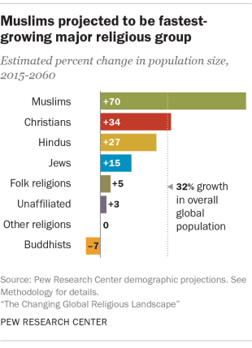
Figure 2 Pace of religion growing
Source: Muslims and Islam: Key findings in the U.S. and around the world. (2017). Retrieved 18 March 2022, from https://www.pewresearch.org/fact-tank/2017/08/09/muslims-and-islam-key-findings-in-the-u-s-and-around-the-world/
The interest of the western countries was not effectively seen through even the formation of the United Nations and the Security Council. The interest of the non-Middle Eastern countries especially the west continually targeted the Muslim nations through conflict creation, disruption, war, terrorism, lack of management in such countries, decisions made only in the favor of some countries, and more. All of this and more are the reasons that have made the influence of Islam in the countries more (Berlin, M2022). Islam was not the religion that came in recent years; it is the second biggest religion and the world's fastest-growing religion. As most of the Middle-easterncountries are fowling the religion of Islam due to which any political change in result in the conflict or not-conflict with Islam. The war in Syria, Yemen, Libya, Afghanistan, Palestine, and more of the Middle Eastern nation faced conflict due to civil wars, poverty, and politics. Islam intervened through the motive of the leaders of the Islamic state who wanted to shape the country according to the Islamic laws and policies which was and are still not in the favor of other nations.

Political Islam in the Middle East and its Revival
One of the most politically disturbing places on Erath would be the Middle East; it is not a notion but a fact, due to the constant ongoing wars, political disturbance, and more. Data shows that the not needed interference of the western countries in the internal issues of the Middle Eastern countries not only started the conflict but transformed into the major and worst conflicts in history. International security was threatened through the disturbance in the Middle Eastern countries and rather than resolving the state issues, interfering and making the wrong decision are the history of the United Nations (Fjærtoft, 2020). For the improvement of the system of politics in the country, it is highly important to look at the issues and the circumstance through and due to which Islam remain active in the Middle Eastern countries. It is highly significant in the case of Islam activities in the Middle Eastern countries as the countries are not promoted and supported by the western countries. The United Nations plays a significant role in the peace maintains in the world issues remain silent on many issues. The current structure of the UN Security Council is not even according to the modern activities and the requirements of the several nations making it obsolete and the method through which none of the countries especially the one that got damaged through the war can rely on it (The UN Security Council, 2022). Some of the UN Security Council issues include the outdated structure that does not support the favor of all the nations which was mentioned in the permeable of the United Nations, also the security council of the United Nations gives importance only to the matters that include the benefits of some of the countries that established the United Nations, beside Security council remain silent and let issues become bigger. There are world-level known issues that are threatening to world peace, including the critical humanitarian crises in Syria, ethnic cleansing going on in Myanmar and other regions (Ligovic, 2018). The failure of the UN Security Council must be acknowledged by it so that the measures must be taken in the way that it will decide which peace all over the world remains prevailing.
The close relationship of Islam in the political activity is due to the reason that the Middle Eastern countries that are subjected to the violence and turbulence in the countries are Islamic nations. Any decision that was made in the Middle Eastern countries should go with the thinking of the principle that is provided by the Islamic laws, which was not supported by the western countries and made the conflict between them. Not only the western countries are responsible for using the name of Islam and pointing the whole religion of billions of people around the world as peaceful and terrorism spreading religion, but other factors lo contributed to using Islam for their benefit. The current instance of that is Afghanistan, from where the United States called out its army back to the country, then the whole country was completely under the control of the Taliban that are representing Islam and Sharia Law according to them (Ullah, & Khalil, 2019). Islam is the major and integral part that could not be separated from the Middle Eastern countries as they are torn apart due to the politics sometimes in the name of oil conflict, sometimes invasion for peace maintenance, and some time for better religious freedom for the people that are living in the land.

Islam as a determinant factor in Politics of Middle East
Fig 2 below shows the regional distribution of Muslims around the world. The data is not current but at least it provides insight into the Muslims that are living in different regions. the whoa life of the Muslim person is according to the teachings of Islam, The politics is one of the factors that highly involves the aspects of Islam as the religion is not given the right to the people to an established new form of government as they like, it. Islam provides several rules and policies through which the laws could be implemented in the country and help the country to manage its state affairs (Esman, & Rabinovich, 2019). For the people of the country in the Middle East, Islam also remains the huge debate as some of the countries including France and others use religious figures and make an unethical comment on the, make cartoons of the Prophets and such practice such acts to spark the anger in the religious sentiments. Such issues in the country are ruled by politics, if the politics of the country is not according to the religion of Islam then the conflict will arise according to the religion as the other forms of government are not good enough through which the government of the country could run the state affairs. The Middle Eastern countries as are mostly Muslim majority states get hurt and religion remains the top priority of the Nations in the Middle East (Weathers, 2018). Due to the negative behavior of the religion and its followers, the people that are in the countries of Middle Eastern keep on revising or practicing the religion more, helping them to give replies according to the religion.
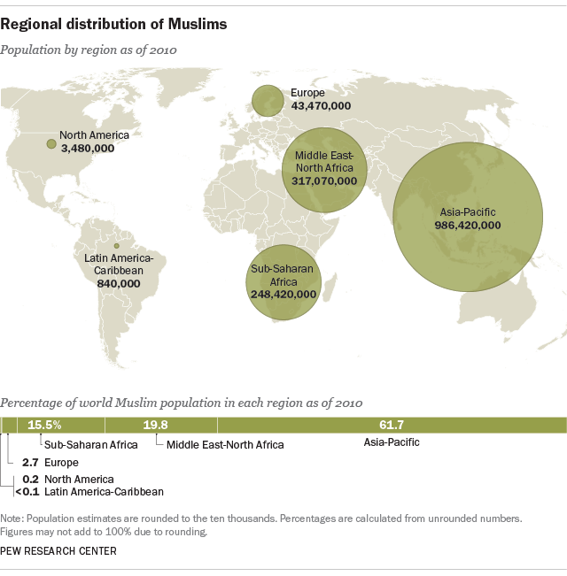
Figure 3 Regional Distribution of Muslims
Source: World Muslim population is more widespread than you might think. (2017). Retrieved 18 March 2022, from https://www.pewresearch.org/fact-tank/2017/01/31/worlds-muslim-population-more-widespread-than-you-might-think/

Further Islam remains highly active in politics as politics use Islam for its benefit. As mentioned several times that people living in the Middle Eastern countries are highly sentimental regarding their religion and in the name of Islam they could do anything, such dedication and belief regarding the aspect of Islam are used for political benefits (Aghaie, 2021). There are many political parties in the government in the countries of the Middle East who use Islam to take votes in the name of the religion. When the political parties incudes the Islamic teaching in their manifesto, it attracts the people that are considered as voters, due to which the people get engaged in the political activities and thought that the political party is highly inspired from the teachings of Islam and will Islamic teachings prevail in the country. Due to the attachment to the religion, Islam gets used by the politics of the country.

Role of Islam and its Significance
The role and the Significance of Islam in the Middle East are high through which the people in the Middle East come closer to each other celebrate the same festivals and have the same mentality. The role of Islam and its remained active status in the Middle East is also due to the huge reason that is political Islam. As western countries do not look the religion as the aspect through which political affairs could be run, the concept of Political Islam was introduced through the revival in the 1970s (Fossati, 2019). Since then many countries and leaders have adopted the state the political Islam through which Islam serves as the political identity and the actions. There are several interpretations of religion and its principles of it. Through the understanding of the principles of Islam by the individual including the policymaker, the people run the country. The provoking acts of the west are controlled and managed through the action of the politics in the country that are given by the Islamic laws and the religion. The religion of Islam plays a significant aspect in the country because through the incorporation of political Islam most of the activities and the action which is done in the Middle-Eastern countries are not principles or according to the interpretation of Islam by them (Ayoob, & Lussier, 2020). Islam is an integral part of politics, in the states that run through the Islamic laws, the nationalism and the concepts including secular nations decline in the Middle-Eastern countries, which was not liked by the western governments at all. Political Islam is used with other terms throughout the world including militant, progressive, radical, and more.
The people in the country of Middle Eastern country want the system if the politics through which they can effectively implement their thoughts through which they can show their response and also remain on the teachings of Islam. The countries that are completely going into the state of secularism revived back to the religion and the practices that promote the teaching of Islam in them, this revival again brings the conflict and the reason was again Islam and this time it is used in the politics properly to that the nationalist mentality secular mentality will get changed.

Foundation of Civil Law
Mu'ammar Al-Qadhdhafi Islamic way of ruling the country of Libya, Gen Zia-ul-Haq in Pakistan, King Faisal in Saudi Arabia, the Islamic revolution of Iran, and more of such historic events that took place and made Islam and politics two sides of one coin. Politics in Islam and its high activities in the Middle East surge drastically through the above-mentioned events. All of the above-mentioned leaders in their respective countries laid the foundation of the civil law using the teachings of Islam, making it a Political aspect of the nation. The western form of government in Middle-Eastern countries is seen as inappropriate to govern life and civil laws (Brooke, & Ketchley, 2018). Islamic resurgence in the middle east is not only the revival of it in terms of some policies but the complete change in the defense system, internal affords, state affairs, the foundation of civil laws and justices, and other aspects of life also got a positive and long-lasting impact on the lives of the people. It is important to note that the people that are living in the middle east also do not want the west to control their political system rather want their system of politics through which they can run the government and other systems smoothly. Through the effective implementation of the governmental laws and rules, the policies will let the people run their life affairs in the light of Islam and help politics to effectively shape the future and the current affairs of government (Ayoob, & Lussier, 2020). Unable to provides the people of the region legitimate ways through which they can be united the western forms of government failed in the countries of the Middle East, which sparked their anger as people aware unable to relate there with the inherited faith and the information or policies they have by the religion.
Implemented the westerns of government in the politics of Middle Eastern countries they got failed as people are against their hypocrisy they did on several times, including the Acknowledge of Israel as the sovereign state, Not understanding the Islamophobia and the issues of it, underlying threats to the people that are unable to digest the new form of government, invasion of the severing states and more of such acts decrease the trust on the forms of government that are provided by the non-middle eastern countries. It is evident from the facts that the government of the western countries tries to control the middle eastern countries and their government for the benefits of their own including the oil, reaching to Pakistan and China, trading from India, and many other benefits that could be very significant and helpful for the countries of the west in the future and also for their economies (Samari, et al 2018). Through the analysis of Islam in politics, it could also be stated that the incidents in history are several that provide the way that promotes Islam and its role in Politics as the significant aspect.
For the countries of the Middle East, it is also important to effectively implement the activities and the policies through which modernization could be the part of the policies and the people will also remain in contact with their religious teaching and Islamic Politics. The effective method is not to confront and show reluctance to the state policies that support modernization (Cesari, 2018); but the way through legitimate way through which the people of the Middle Eastern countries can positively accept the process of modernization. The intellectual minds of the country and the thinkers should opt. this duty helps in maintaining the balance between Islamic teaching and the modern requirements of the world. Also, it will help the Middle Eastern countries to get accepted by the major western nations as not the state that spreads terror but the nations that are highly disciplined and principle-driven (Tomory, 2019). Currently, according to the analysis, most of the middle eastern countries are facing conflict and they are neither in the state of implementing any forms of government, nor they can implement their own rigid or relaxed policies, due to which, significantly, the countries that are facing the conflict should effectively lookout for the solution and the Islamic way through which their population will also remain settled.
It is the general concept due to the situation and tension between the western nations and the middle eastern that the people are not fine to implement their methods and also do not want them to guide the government currently, due to which the politics and Islam should get merged in the way through which the policies of the state will remain highly beneficial for the state. Islam is the significant aspect of the people that are in Middle Eastern countries, as Islam originates from the Arab region and the Religious and Sacred sites are there (Aksoy, & Billari, 2018). People feel connected to the Middle Eastern nations, which lie with the greater responsibility of making the decision and implementing the policies which are very effective for the countries in the Middle East. The policies should be the comprehensive ones through which the state affairs and the civil laws will remain effective.

Conclusion
From the above analysis of Islam and its role in politics, it is highly evident that several reasons played a crucial role in politics as well as in shaping the future countries that are included in the Middle Eastern countries. Through the results, it is highly evident that the policies of the west are not in the favor of the countries that are included in the Middle East and the countries that have recognized it. Islam is deep-rooted in the nations of the Middle East and their policies, lives, and way of managing state affairs are effectively done in the light of their interpretation of Islam. The role of the United Nations is also highly negative in the aspect of solving and maintaining long-lasting peace in the cases of Middle Eastern conflicts. Islam is found to be not the religion that is introduced a few hundred years ago but is one of the religions that have influenced billions of people around the globe. the role of Political Islam is also identified thoroughly through which the Middle-eastern countries can not only survive the conflict situations, but they can progressively remain the part of the modern world without confronting or showing rigid resistance to the government systems, and policies introduced by western nations.

Reference
Aghaie, K. S. (2021). Islamic-Iranian nationalism and its implications for the study of political Islam and religious nationalism. In Rethinking Iranian Nationalism and Modernity (pp. 181-204). University of Texas Press.
Aksoy, O., & Billari, F. C. (2018). Political Islam, marriage, and fertility: evidence from a natural experiment. American Journal of Sociology, 123(5), 1296-1340.
Ayoob, M., & Lussier, D. N. (2020). The Many Faces of Political Islam: Religion and Politics in Muslim Societies. University of Michigan Press.
Ayoob, M., & Lussier, D. N. (2020). The Many Faces of Political Islam: Religion and Politics in Muslim Societies. University of Michigan Press.
Bannazadeh Baghi, H., Alinezhad, F., Kuzmin, I., & Rupprecht, C. E. (2018). A perspective on rabies in the Middle East—Beyond Neglect. Veterinary sciences, 5(3), 67.
Berlin, M. P., Desai, R. M., & Olofsgård, A. (2022). Trading Favors? UN Security Council Membership and Subnational Favoritism in Aid Recipients (No. 2022-7). Stockholm School of Economics, Mistra Center for Sustainable Markets (Misum).
Brooke, S., & Ketchley, N. (2018). Social and institutional origins of political Islam. American Political Science Review, 112(2), 376-394.
Budiwati, A. (2020). HISTORICAL-ASTRONOMIC PROVISION OF BIRTH AND DEATH PROPHET MUHAMMAD SAW. Al-Hilal: Journal of Islamic Astronomy, 1(1).
Cesari, J. (2018). What is political Islam?. Boulder: Lynne Rienner Publishers.
Cohen, M. J. (2018). Fighting world war three from the Middle East: Allied contingency plans, 1945–1954. Routledge.
Esman, M. J., & Rabinovich, I. (Eds.). (2019). Ethnicity, pluralism, and the state in the Middle East. cornell University press.
Fjærtoft, T. E. (2020). Envision, not argue: Innovating EU policy after the failures of Libya and Syria. European Foreign Affairs Review, 25(1).
Fossati, D. (2019). The resurgence of ideology in Indonesia: Political Islam, Aliran and political behaviour. Journal of Current Southeast Asian Affairs, 38(2), 119-148.
Ligovic, K. (2018). Silence in Syria: A examination of the UN: s diplomacy in the Syrian civil war.
Mansour, I. (2018). Direct and inferred influences of the Silk Roads on the ‘golden age’of the Abbasid Caliphate. Asian Journal of Comparative Politics, 3(3), 246-257.
Mughul, M. Y. DEVELOPMENT OF THE ISLAMIC ARCHITECTURE WITH SPECIAL REFERENCE TO THE OTTOMAN TURKS.
Muslims and Islam: Key findings in the U.S. and around the world. (2017). Retrieved 18 March 2022, from https://www.pewresearch.org/fact-tank/2017/08/09/muslims-and-islam-key-findings-in-the-u-s-and-around-the-world/
Samari, G., Alcalá, H. E., & Sharif, M. Z. (2018). Islamophobia, health, and public health: a systematic literature review. American journal of public health, 108(6), e1-e9.
The UN Security Council. (2022). Retrieved 18 March 2022, from https://www.cfr.org/backgrounder/un-security-council
Tomory, I. (2019). The cultural context of adaptation western education in East-Africa: paradoxons and missing links. West East Journal of Social Sciences, 8(2), 133-145.
Ullah, H., & Khalil, M. H. (2019). The impact of US invasion in Afghanistan on the tribal culture of Waziristan. Pakistan Journal of History and Culture, 40(1), 123-142.
Vulture, C. (2022). Why is the Middle East called the Middle East?. Retrieved 18 March 2022, from https://www.commisceo-global.com/blog/why-is-the-middle-east-called-the-middle-east
Weathers, E. (2018). Spirituality and health: A Middle Eastern perspective. Religions, 9(2), 33.
World Muslim population is more widespread than you might think. (2017). Retrieved 18 March 2022, from https://www.pewresearch.org/fact-tank/2017/01/31/worlds-muslim-population-more-widespread-than-you-might-think/

